# Mini Project Report

on

“Fruit disease detection using image processing”

Submitted in partial fulfillment for the award of degree

of

**BACHELER OF TECHNOLOGY**

in

**INFORMATION TECHNOLOGY**

Submitted by

1. **Mohsina Akbar Mulani (20141153)**
2. **Rani Uttam Kamble (20141157)**

Under the Guidance of

**Prof. N. M. Mule**



**Government College of Engineering, Karad**

(An Autonomous Institute of Government of Maharashtra)

# Academic Year 2022-2023

**Government College of Engineering, Karad**

(An Autonomous Institute of Government of Maharashtra)

# Department of Information Technology

***CERTIFICATE***

This is to certify that the project entitled “ Fruit Disease Detection using Image Processing ” has been carried out by team:

* + 1. **Mohsina Akbar Mulani (20141153)**
    2. **Rani Uttam Kamble (20141157)**

of T. Y. B.Tech IT class under the guidance of Prof. N. M. Mule during the academic year 2021-22 (Sem-V).

|  |  |
| --- | --- |
| **Prof.N.M.Mule** | **Dr. S. J. Wagh** |
| ProjectGuide | Head Information Technology Department |
|  |  |
| External  Examiner |  |

**ACKNOWLEDGEMENT**

Apart from individual efforts, the success of any project depends largely on the encouragement and guidelines of many others. We take this opportunity to express our gratitude to the people who have been instrumental throughout the project work.

It is our privilege to express our gratitude towards our project guide**,** Prof. N.M. Mule , for their valuable guidance, encouragement, inspiration and whole-hearted cooperation throughout the project work. We thank him for being a motivation through all our highs and importantly, our lows.

We deeply express our sincere thanks to our Head of Department Dr. S. J. Wagh for encouraging and allowing us to present the project on the topic “ Fruit Disease Detectionusing Image Processing ” and providing us with the necessary facilities to enable us to fulﬁll our project requirements as best as possible. We take this opportunity to thank all faculty members and staff of Department of Information Technology, who have directly or indirectly helped our project.

We pay our respects to honorable Principal **Dr. A. T. Pise** for their encouragement. Our thanks and appreciations also go to our family and friends, who have been a source of encouragement and inspiration throughout the duration of the project.

**ABSTRACT**

Agriculture played a major role in the economy of many developing countries. Apple falls under the commercial crops as a fruit that will be grown worldwide. In the whole growth cycle of apples, there are many types of apple diseases, therefore, recognition and determination of these illnesses are essential. Convolutional Neural Network is used to detect the diseases in the apple fruit. In CNN feature extraction and disese classification isperformed simultaneously. The Deep learning algorithm Convolutional Neural Network algorithms is used to test & train the data. The tool used for implementation are Anaconda Jupyter notebook, Visual Studio Code and Python Language. It is free of cost and the most popular software of Python programming. The dataset contains both healthy and unhealthy apple fruit images. The outcomes visualize the higher arrangement exactness of the proposed CNN model. At last, the outcome will be generated in the form of loss, accuracy, precision, recall, sensitivity, and specificity.

II

**LIST OF FIGURES**

|  |  |  |
| --- | --- | --- |
| Table. No. | Table Caption | Page No. |
| 1 | Flowchart |  |
| 2 | Block diagram |  |

III

**ABBREVATIONS**

|  |  |
| --- | --- |
| Acronym | Definition |
| CNN | Convolutional Neural Network |
| DL | Deep Learning |
| ML | Machine Learning |

IV

**TABLE OF CONTENTS**

|  |  |  |
| --- | --- | --- |
| Topics | | Page No. |
| * Abstract * List of Figures * Abbreviations |  | I  II  III |

|  |  |  |
| --- | --- | --- |
| Sr. No. | Table of Contents | Page No. |
| Chapter 1 | Introduction…………………………………………….. |  |
| 1.1 | Background | 1 |
| 1.2 | Importance of Project | 1 |
| 1.3 | Motivation | 2 |
| 1.4 | Scope | 3 |
| 1.5 | Expected Outcomes | 4 |
| Chapter 2 | Literature Survey………………………………………… |  |
| 2.1 | Detection of Strawberry Diseases Using Convolutional Neural Network [7] |  |
| 2.2 | A Deep Neural Network-based disease detection scheme for Citrus fruits [5] |  |
| Chapter 3 | Related Theory and Problem Definition…….…………… |  |
| 3.1 | Problem Definition |  |
| 3.2 | Related Theory |  |
| Chapter 4 | Design Methodology………………………...................... |  |
| 4.1 | Proposed System Architecture |  |
| 4.2 | Internal Logic of System |  |
| 4.3 | Technical Specifications |  |
| Chapter 5 | Implementation…………………………………………… |  |
| 5.1 | Implementation of proposed System |  |

|  |  |  |
| --- | --- | --- |
| Chapter 6 | Result and Discussion…………………………………… |  |
| 6.1 | Result |  |
| 6.2 | Discussion |  |
| Chapter 7 | Conclusion and Future Scope……………………………. |  |
| 7.1 | Conclusion |  |
| 7.2 | Future Scope |  |
|  | References………………………………………………… |  |

# Chap

**Chapter 1**

**INTRODUCTION**

Agriculture is essential to the harvesting of any culture. Agriculture is, in fact, critical to human civilization. Field prevalence and water management in the soil must be maintained on a regular basis in order to achieve the goal of good production. Fruit disease has a significant impact on product quality and quantity. The most significant impediment in this area is fruit disease.

* 1. **Importance of the project:**

In order to analyze the degradation of fruit crops, image processing techniques are applied. The proposed system is tasked with identifying the flaws in the fruit photos. Normal Smartphone Cameras can be used to obtain the dataset. Early identification of fruit diseases is critical for economic reasons. Deep Learning can detect and classify illnesses early, limiting disease spread and improving cure rates. Blotch, Scab, and Rot are common disease in apples fruits. Manual inspection is sluggish, prone to errors, and requires a lot of personnel and time to avoid the flaws during manual classification, researchers have presented an image detection approach to classify infected fruits from healthy fruits to enhance accuracy.

* 1. **Motivation:**

India is an agrarian economy. Agriculture shares 17% of the country’s GDP .Increasing farm productivity is the need of the hour. Annually more than one-third of the crop yield is affected by the diseases in India. Fruit diseases can cause major losses in yield and quality appeared in harvesting.

* 1. **Scope:**

Early identification of fruit diseases is critical for economic reasons. Deep Learning can detect and classify illnesses early, limiting disease spread and improving cure rates. Rot, scab, and blotch are common diseases in apples. Manual inspection is sluggish, prone to errors, and requires a lot of personnel and time. As a result, there are more mistakes made when grading fruits for export. To avoid the flaws during manual classification, researchers have presented an image detection approach to classify infected fruits from healthy fruits to enhance accuracy.

* 1. **Expected Outcome:**

* Farmers are able to know various apple fruit diseases.
* Develops interventions to protect plants by detecting fruit disease.
* Reduce crop losses and improve food security and yield of farm.

**Chapter 2**

**LITERATURE SURVEY**

* 1. **Detection of Strawberry Diseases Using a Convolutional Neural Network [7]**

The strawberry (*Fragaria* × *ananassa* Duch.) is a high-value crop with an annual cultivated area of ~500 ha in Taiwan. Over 90% of strawberry cultivation is in Miaoli County. Unfortunately, various diseases significantly decrease strawberry production. The leaf and fruit disease became an epidemic in 1986. From 2010 to 2016, anthracnose crown rot caused the loss of 30–40% of seedlings and ~20% of plants after transplanting. The automation of agriculture and image recognition techniques are indispensable for detecting strawberry diseases. We developed an image recognition technique for the detection of strawberry diseases using a convolutional neural network (CNN) model. CNN is a powerful deep learning approach that has been used to enhance image recognition. In the proposed technique, two different datasets containing the original and feature images are used for detecting the following strawberry diseases—leaf blight, gray mold, and powdery mildew. Specifically, leaf blight may affect the crown, leaf, and fruit and show different symptoms. By using the ResNet50 model with a training period of 20 epochs for 1306 feature images, the proposed CNN model achieves a classification accuracy rate of 100% for leaf blight cases affecting the crown, leaf, and fruit; 98% for gray mold cases, and 98% for powdery mildew cases. In 20 epochs, the accuracy rate of 99.60% obtained from the feature image dataset was higher than that of 1.53% obtained from the original one. This proposed model provides a simple, reliable, and cost-effective technique for detecting strawberry diseases.

**2.2 A Deep Neural Network-based disease detection scheme for Citrus fruits [5]**

One of the most significant factors is the quality evaluation of agricultural products in supporting their marketability and controlling waste management. To classify the fruits into healthy and defected class, deep learning algorithms have been implemented to perform citrus disease detection. This study aims to use the dense CNN algorithm to detect and provide an effective method for detecting the apparent defects of citrus fruit. Citrus fruit images are collected and put in two classes of good and damaged ones, to recognize and categorize the image dataset. Firstly, a dense CNN model was used without doing preprocessing and data augmentation on 150 images and achieved an accuracy of 67 percent but the proposed model has used data augmentation and pre-processing to enhance the CNN performance and have used 1200 images. Further, the proposed model is compared with the dense model where data augmentation and pre-processing techniques have not been used. The overall accuracy of the proposed model is 89.1%. The results show that techniques of data augmentation and preprocessing have delivered promising insights to estimate citrus fruit's damages.

**Chapter 3**

**RELATED THEORY AND PROBLEM DEFINITION**

* 1. **Problem Definition:**

The basic idea behind the project is to develop project for detecting various apple fruit diseases . This platform is intended to be used as project guiding tool in engineering and all other studies. The application is built using HTML, CSS , Javascript and Flask App.

* 1. **Related Theory**

CNN is a mathematical model that can simulate brain function and neural interactive connections based on a convolution process. In CNN, the image was obtained from the input terminal and the image features are filtered out to the pooling layer through the convolution layer to sort out the new image features. The convolution and pooling are one layer. In the last layer, the final features are fully connected and identified according to the CNN algorithm. We used CNN to detect the different apple diseases.

Before inserting the input matrices into the neural network, the images were separated into the original and feature images. The original image dataset was used to instruct the neural network to focus on the neighborhood information and train it to extract necessary features through supervised backpropagation training. For the output side, the neural network was trained like a pathologist making a diagnosis. This can be considered as an expert training method to convert human action into a computer algorithm.

**Chapter 4**

**DESIGN METHODOLOGY**

* 1. **Proposed system Architecture**

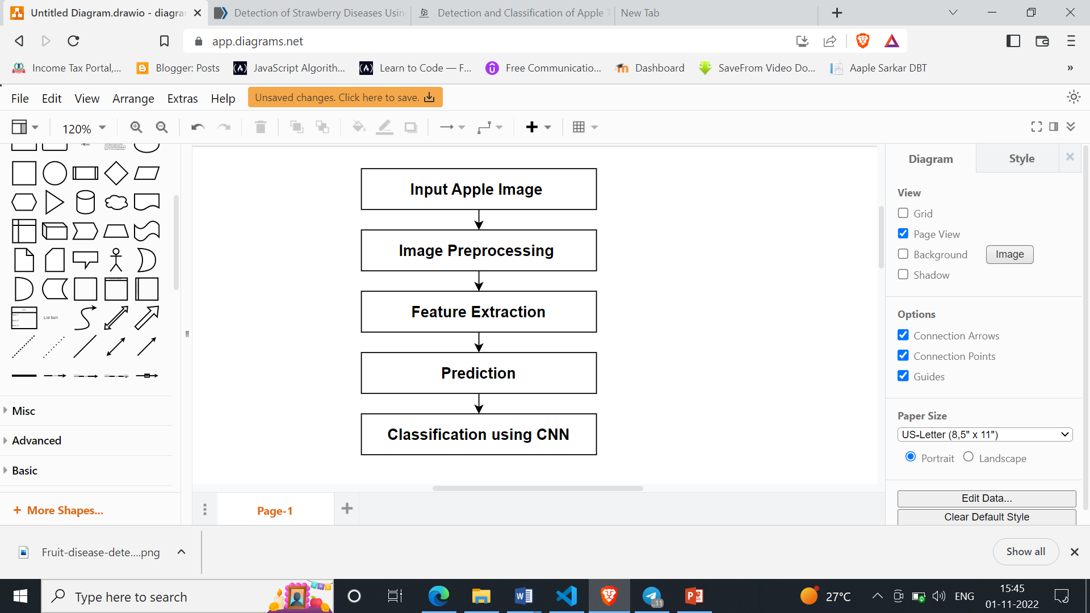

Flowchart: Proposed System Architecture

* 1. **Internal Logic of system:**

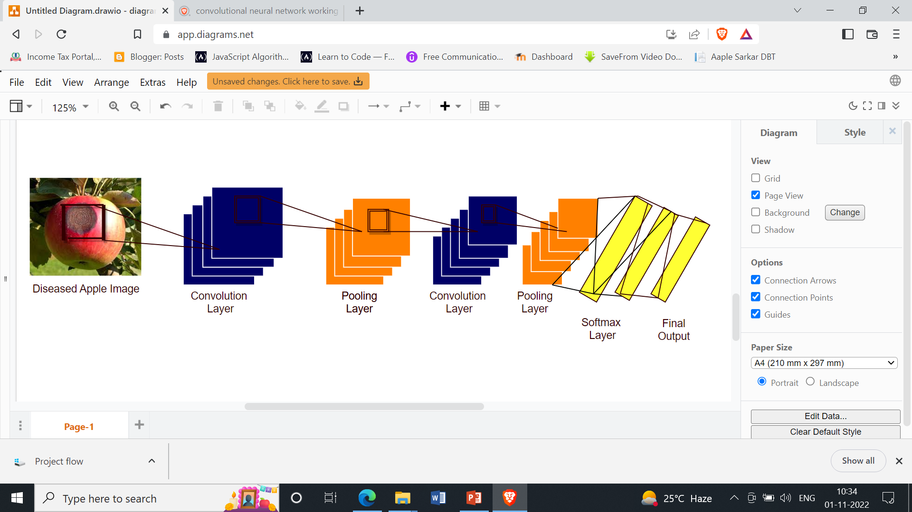

Fig. Convolutional Neural Network for Apple Fruit Disease Detection

* 1. **Technical Specifications**

**Operating Systems:** Windows 10

**Software Requirements:** Visual Studio Code, Github, Jupyter notebook

**Languages used for Front-end:** HTML, CSS, JavaScript

**Back-end:** flask

**Chapter 5**

**IMPLEMENTATION**

* 1. **Implementation of Proposed System:**

Here’s a look at the [key stages](https://analyticsindiamag.com/convolutional-neural-network-image-classification-overview/) that help machines to identify patterns in an image:

**Convolution**: Convolution is performed on an image to identify certain features in an image. Convolution helps in blurring, sharpening, edge detection, noise reduction and more on an image that can help the machine to learn specific characteristics of an image.

**Pooling:** A convoluted image can be too large and therefore needs to be reduced. Pooling is mainly done to reduce the image without losing features or patterns.

**Flattening**: Flattening transforms a two-dimensional matrix of features into a vector of features that can be fed into a neural network or classifier.

**Full-Connection:** Full connection simply refers to the process of feeding the flattened image into a neural network

**Installing Packages:**

TensorFlow: Install TensorFlow for the desired platform from [https://www.TensorFlow.org/install](https://www.tensorflow.org/install)

Keras :

**Importing the Libraries and Packages:**

    from keras.models import Sequential

    from keras.layers import Convolution2D

    from keras.layers import MaxPooling2D

    from keras.layers import Flatten

    from keras.layers import Dense

**Initialising the CNN:**

The first step in creating a Neural network is to initialise the network using the Sequential Class from keras.

   model = Sequential()

**Convolutional Layer**

    model.add(Convolution2D(filters = 32, kernel_size**=**(3, 3), input_shape = (64, 64, 3), activation = ‘relu’)

Arguments:

* filters : Denotes the number of Feature detectors.
* kernel_size : Denotes the shape of the feature detector. (3,3) denotes a 3 x 3 matrix.
* input _shape : standardises the size of the input image
* activation : Activation function to break the linearity

**Pooling Layer**

 model.add(MaxPooling2D(pool_size = (2, 2)))

Arguments:

* pool_size : the shape of the pooling window.

**Adding a second layer of Convolution and Pooling**

    model.add(Convolution2D(32, 3, 3, activation = ‘relu’))

    model.add(MaxPooling2D(pool_size = (2, 2)))

**Flattening Layer**

    model.add(Flatten())

**Full-Connection Layer**

**Adding the Hidden layer**

 model.add(Dense(units = 128, activation = ‘relu’))

**Adding the Output Layer**

    model.add(Dense(units = 1, activation = ‘sigmoid’))

Arguments:

* units: Number of nodes in the layer.
* activation : the activation function in each node.

**Compiling the CNN**

    model.compile(optimiser = ‘adam’,

                                 loss = ‘binary_crossentropy’,

                                 metrics = [‘accuracy’])

Arguments:

* Optimiser: the Optimiser  used to reduce the cost calculated by cross-entropy
* Loss: the loss function used to calculate the error
* Metrics: the metrics used to represent the efficiency of the model

**Generating Image Data**

 from keras.preprocessing.image import ImageDataGenerator

train_datagen = ImageDataGenerator(rescale = 1./255, shear_range = 0.1, zoom_range = 0.2, horizontal_flip = True)

test_datagen = ImageDataGenerator(rescale = 1./255)

Arguments:

* rescale: Rescaling factor. Defaults to None. If None or 0, no rescaling is applied, otherwise we multiply the data by the value provided
* shear_range: Shear Intensity. Shear angle in a counter-clockwise direction in degrees.
* zoom_range: Range for random zooming of the image.

**Fitting images to the CNN**

[**Flow_from_directory**](https://keras.io/preprocessing/image/)**:**

This function lets the classifier directly identify the labels from the name of the directories the image lies in.

training_set = train_datagen.flow_from_directory(‘dataset/training_set’, target_size = (64, 64), batch_size = 32, class_mode = ‘categorical’)

test_set = test_datagen.flow_from_directory(‘dataset/test_set’, target_size = (64, 64), batch_size = 32, class_mode = ‘categorical’)

Arguments:

* directory: Location of the training_set or test_set
* target_size : The dimensions to which all images found will be resized.Same as input size.
* Batch_size : Size of the batches of data (default: 32).
* Class_mode : Determines the type of label arrays that are returned.One of “categorical”, “binary”, “sparse”, “input”, or None.

**Training and Evaluating the model**

 model.fit_generator(training_set,_samples_per_epoch = 2000, nb_epoch = 15, validation_data = test_set, nb_val_samples = 200)

Arguments:

* generator : A generator sequence used to train the neural network(Training_set).
* Samples_per_epoch : Total number of steps (batches of samples) to yield from generator before declaring one epoch finished and starting the next epoch. It should typically be equal to the number of samples of your dataset divided by the batch size.
* Nb_epoch : Total number of epochs. One complete cycle of predictions of a neural network is called an epoch.
* Validation_data :  A generator sequence used to test and evaluate the predictions of the  neural network(Test_set).
* Nb_val_samples :Total number of steps (batches of samples) to yield from validation_data generator before stopping at the end of every epoch.

The above function trains the neural network using the training set and evaluates its performance on the test set. The functions returns two metrics for each epoch ‘acc’ and ‘val_acc’ which are the accuracy of predictions obtained in the training set and accuracy attained in the test set respectively.

**Chapter 6**

**RESULT AND DISCUSSION**

* 1. **Result:**

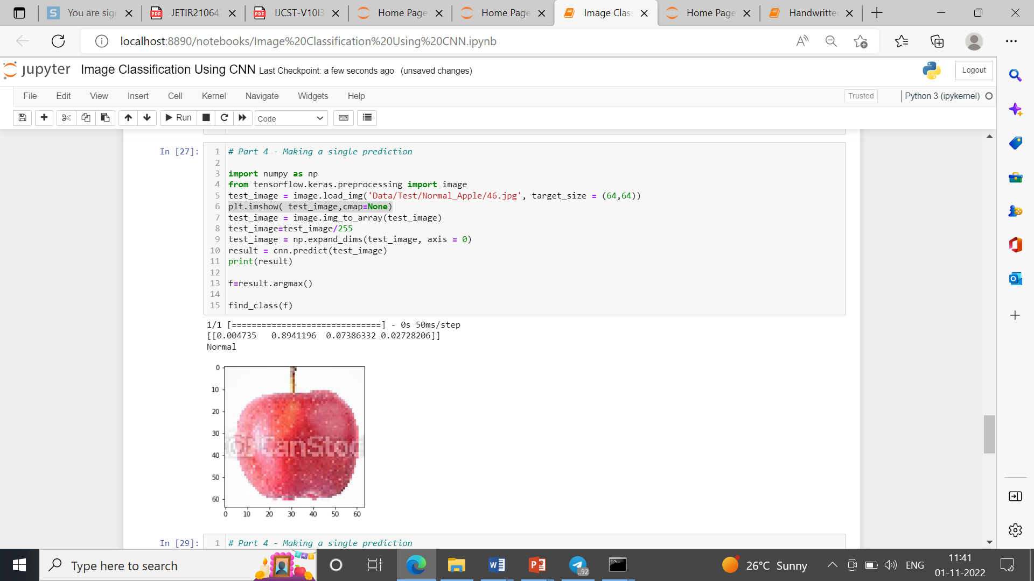

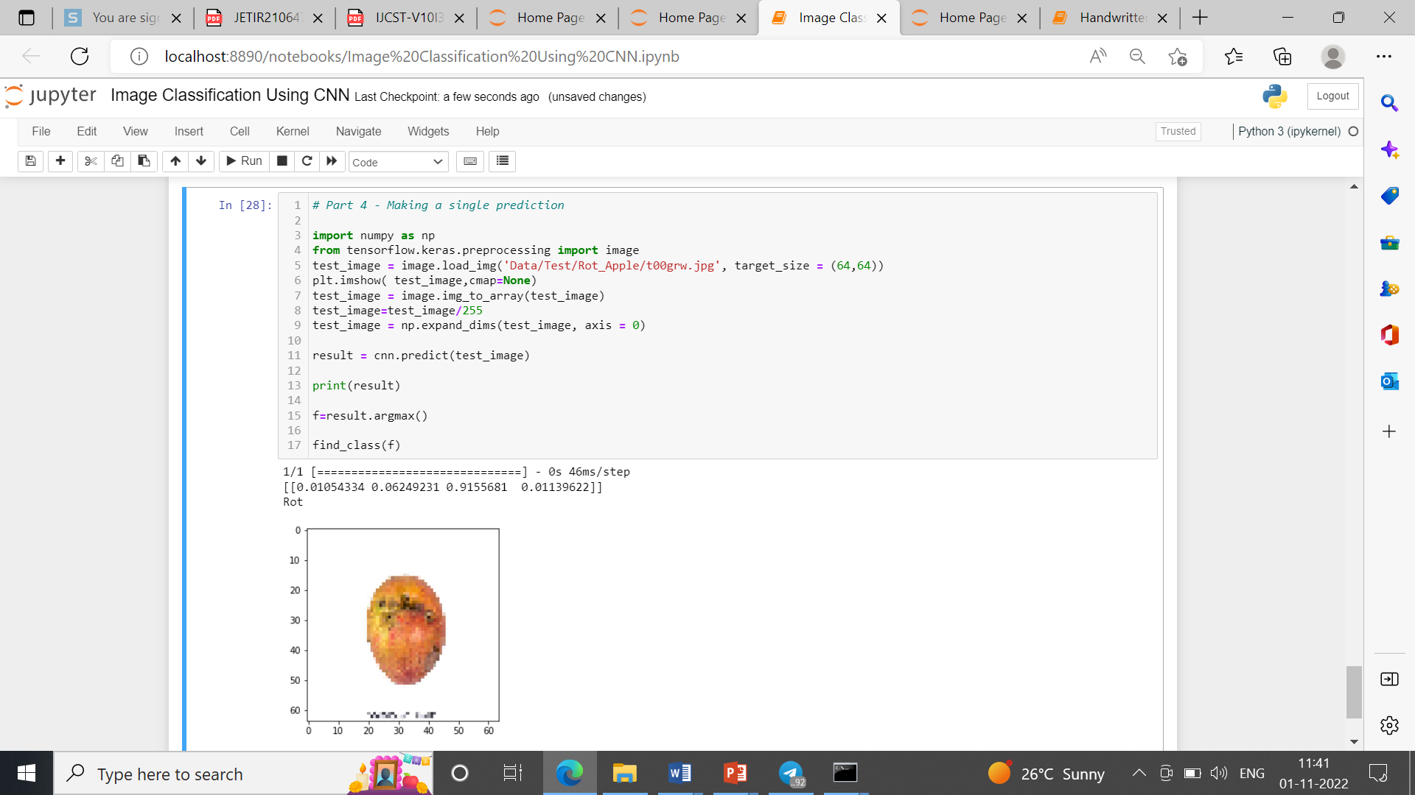

* 1. **Discussion:**

We have put the software code in Jupyter Notebook (Python Programming) in Anaconda Navigator IDE. We used a local host server to upload the images of the apples. The results are as displayed below:

In Deep Learning projects using Python Programming Language, the model is to be trained with trainable images and the training for each image is to be done many times in iterations in order to increase the accuracy of the prediction when test images are used or in real world application of the Deep Learning project. Each training iteration is called an Epoch. More the number of Epochs, more is the accuracy but increasing the number of Epochs substantially also causes the problem of Overfitting. Hence an optimum number of Epochs need to use. In our project after a number of trails and errors we arrived at an optimum number of 10 Epochs.

**Chapter 7**

**CONCLUSION AND FUTURE SCOPE**

**7.1 Conclusion**

* Apple fruit disease detection can be literally achieved with the help of image processing.
* The Use of CNN algorithms paves an easy way to detect the disease on the apple fruits and helps to classify the diseases of apple.
* This approach can easily identify and classify the fruits using image processing techniques.
* The leading objective of our project is to boost the worth of fruit disease detection.

* 1. **Future Scope**

The major reason affecting apple production is the occurrence of apple diseases. In order to improve the fruit production of the valley, it is necessary to detect the onset of diseases on time and accordingly advise the farmers to act based on the expert suggestions and recommendations.

Smart Fruit Disease Detection and Recommendation System is an intelligent system (app-based) that uses state-of-the-art deep learning techniques for automatic detection of various diseases from fruits, leaves, tree trunks, etc. Post detection, the smart recommendation system shall provide the farmer with the best expert opinion and suggestions to deal with the detected diseases. Moreover, important data (fruit type, detected disease, severity, location, weather info etc.) shall be sent to the cloud for further analysis which shall help in disease forecasting in the future.

**REFERENCES**

* + 1. S. R. Dubey and A. S. Jalal, "Detection and Classification of Apple Fruit Diseases Using Complete Local Binary Patterns," 2012 Third International Conference on Computer and Communication Technology, 2012, pp. 346-351, DOI: 10.1109/ICCCT.2012.76.
    2. S. K. Behera, L. Jena, A. K. Rath, and P. K. Sethy, "Disease Classification and Grading of Orange Using Machine Learning and Fuzzy Logic," 2018 International Conference on Communication and Signal Processing (ICCSP), 2018, pp. 0678-0682, DOI: 10.1109/ICCSP.2018.8524415.
    3. Bekkanti, V. S. R. K. P. Gunde, S. Ital, G. Parasa, and C. M. A. K. Z. Basha, "Computer-Based Classification of Diseased Fruit using K-Means and Support Vector Machine," 2020 Third International Conference on Smart Systems and Inventive Technology (ICSSIT), 2020, pp. 1227-1232, DOI: 10.1109/ICSSIT48917.2020.9214177.
    4. Doh, D. Zhang, Y. Shen, F. Hussain, R. F. Doh and K. Ayepah, "Automatic Citrus Fruit Disease Detection by Phenotyping Using Machine Learning," 2019 25th International Conference on Automation and Computing (ICAC), 2019, pp. 1-5, DOI: 10.23919/IConAC.2019.8895102.
    5. V. Kukreja and P. Dhiman, "A Deep Neural Network based disease detection scheme for Citrus fruits," 2020 International Conference on Smart Electronics and Communication (ICOSEC), 2020, pp. 97-101, DOI: 10.1109/ICOSEC49089.2020.9215359.
    6. Ahmad, J., Jan, B., Farman, H., Ahmad, W., & Ullah, A. (2020). Disease detection in plum using convolutional neural network under true field conditions. Sensors, 20(19), 5569. Doi: https://doi.org/10.3390/s20195569
    7. Xiao, J. R., Chung, P. C., Wu, H. Y., Phan, Q. H., Yeh, J. L. A., & Hou, M. T. K. (2020). Detection of strawberry diseases using a convolutional neural network. Plants, 10(1), 31. <https://doi.org/10.3390/plants10010031>
    8. Shafi, A. S. M., Rahman, M. B., & Rahman, M. M. (2018). Fruit disease recognition and automatic classification using MSVM with multiple features. Int J Comput Appl, 181(10), 0975-8887.
    9. JMCOE, J. (2017). Detection and Classification of Apple Fruit Diseases using K-means clustering and Learning Vector Quantization Neural Network.

https:[//www.ijsdr.org/papers/IJSDR17060](http://www.ijsdr.org/papers/IJSDR17060)